TeamPulse
A Collaboration Platform with Real-Time Team
Engagement Ranking
PROJECT ABSTRACT
Built with Spring Boot (Web · Security · MySQL · Lombok) and React

TEJ ROHIT PARUCHURI
tejrohitparuchuri@gmail.com | 24eg105r02@anurag.edu.in
9676112334
III CSE-R

1. Abstract
TeamPulse is a team collaboration and messaging platform, similar in spirit to Slack, that lets an organization create workspaces, open topic-based channels inside them, and communicate through real-time messaging. What differentiates TeamPulse from a conventional chat tool is a built-in engagement ranking system: every workspace continuously tracks how involved each member is — through messages sent, replies, reactions, huddle participation, and active time — and converts that activity into a single Engagement Score. Members of a workspace are then displayed in a ranked list, ordered from the most to the least involved contributor, with a colour-coded progress bar that gives an instant visual read of relative engagement.
The goal of the platform is to give team leads and workspace admins a lightweight, always-on view of participation health without needing separate analytics tooling, while giving individual members a light, gamified nudge to stay engaged. The system is built on a Spring Boot backend exposing a secured REST API, backed by a MySQL relational database, with a React single-page frontend that renders workspaces, channels, live chat, and the ranking view. Authentication and authorization are handled through Spring Security using stateless JWT tokens, and real-time features (chat delivery and live ranking updates) are delivered over WebSockets.
This document presents the project abstract, the high-level system design, the backend request/engagement-tracking workflow, the authentication and authorization flow, a rough UI concept for the ranking screen, and the Entity–Relationship (ER) model underlying the data layer. No implementation code is included; the intent is to communicate the architecture and design decisions clearly enough to guide implementation.

2. Problem Statement & Objectives
Most team chat tools optimize purely for message throughput and make no attempt to surface who is actually driving collaboration within a team. Managers are left guessing about participation, and quieter-but-valuable contributions (steady replies, consistent presence) are just as invisible as genuine disengagement. TeamPulse addresses this by treating engagement as a first-class, continuously computed metric rather than an after-the-fact report.

2.1 Objectives
- Provide real-time, Slack-like messaging inside workspaces and channels.
- Continuously measure member engagement from natural product usage (messages, replies, reactions, huddles, active time) without extra manual effort from members.
- Rank workspace members by involvement and visualize the ranking with an intuitive, colour-coded progress bar relative to the top contributor.
- Secure every API endpoint with authentication (who you are) and authorization (what you're allowed to do) so that ranking and workspace data stay private to workspace members.
- Keep the architecture modular (Controller → Service → Repository) so the ranking engine can evolve independently of chat features.

3. System Design — High-Level Architecture
TeamPulse follows a classic layered, client–server architecture. The React frontend never talks to the database directly; every read or write passes through the Spring Boot REST API, which is fronted by a Spring Security filter chain that authenticates the caller before any business logic executes. A parallel WebSocket channel is used for anything that needs to feel instantaneous — new chat messages and live ranking-bar updates — so that members see each other's activity and rank changes without refreshing the page.
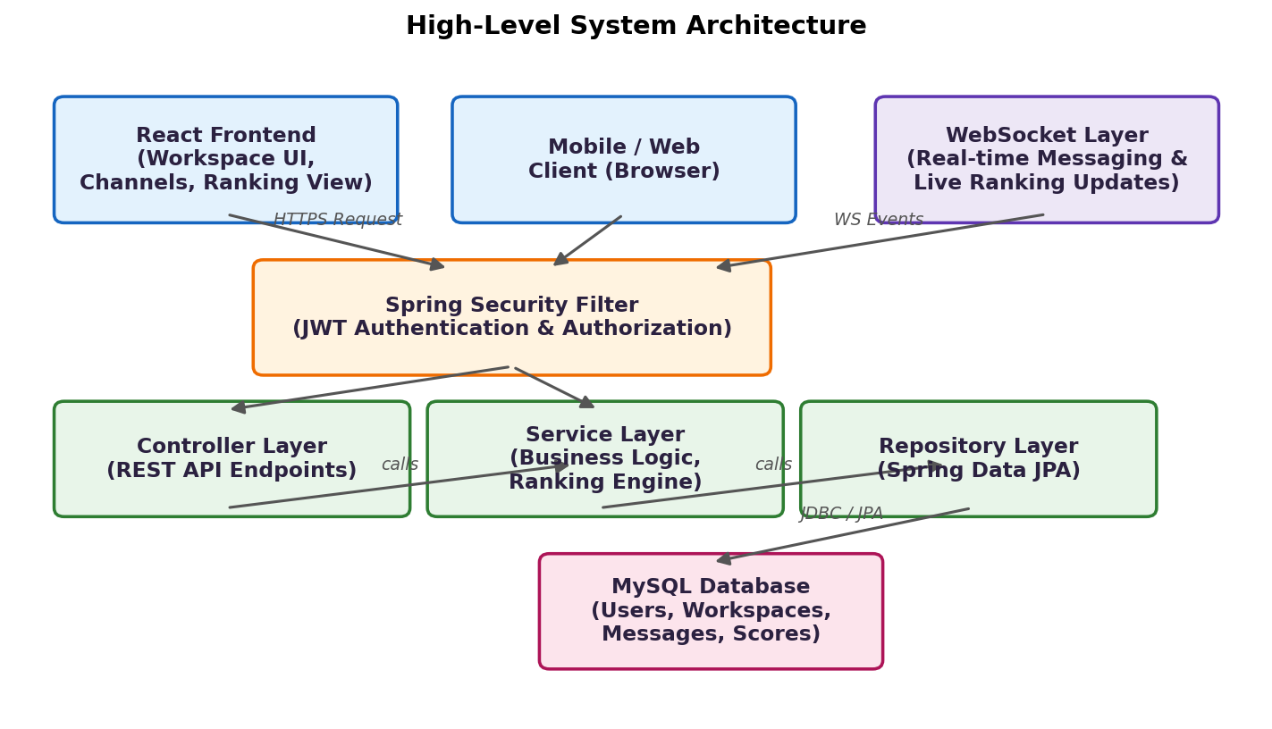
Figure 1. High-level system architecture — client, security, service layers, and database.
The backend itself is organised into the standard Spring layers:
- Controller layer — exposes REST endpoints (e.g. workspace, channel, message, ranking endpoints), validates request shape, and delegates to services. Contains no business logic.
- Service layer — owns business rules: creating workspaces, posting messages, and — most importantly — the Ranking Engine that recalculates engagement scores.
- Repository layer — Spring Data JPA repositories that translate service calls into SQL against MySQL, keeping persistence concerns out of the business logic.
- Security layer — a JWT filter sitting in front of the controllers, described in detail in Section 6.

4. Engagement Ranking Mechanism
Every meaningful action a member takes inside a workspace is recorded as an Engagement Event with an associated weight. The Ranking Engine (part of the Service layer) periodically — and on every new event — recomputes a member's cumulative Engagement Score as a weighted sum of their events over the tracked period (e.g. the current week or month, depending on configuration). A suggested starting weight scheme is shown below; these are configurable per workspace rather than hard-coded.
Engagement Event | Suggested Weight | Rationale
Message sent | 2 pts | Core participation signal
Reply / thread response | 3 pts | Encourages discussion, not just broadcasting
Reaction added | 1 pt | Lightweight acknowledgement of engagement
Huddle / call joined | 5 pts | High-effort, synchronous participation
Active minutes online | 0.1 pt/min | Rewards sustained presence without over-weighting idle time
Channel/file shared | 2 pts | Contribution of resources to the team

Once every member's raw score is computed, members are sorted in descending order within their workspace. The member with the highest score is displayed at #1 with a full progress bar; every other member's bar length is drawn relative to that top score (member_score ÷ top_score × 100%), which is what produces the '#1 full bar, everyone else scaled beneath it' effect requested for the ranking view. Recomputation is incremental (only the affected member's score is touched on a new event, then the workspace list is re-sorted), so the ranking stays live without expensive full recalculation.

5. Rough UI Concept — Workspace Ranking View
The mockup below sketches the workspace info screen: a sidebar listing channels, and a main panel showing the ranking table. Rank #1 (Liam Vance) is drawn with a full-width bar; every other member's bar is scaled relative to Liam's score, and each bar is coloured according to the member's percentage of the top score.
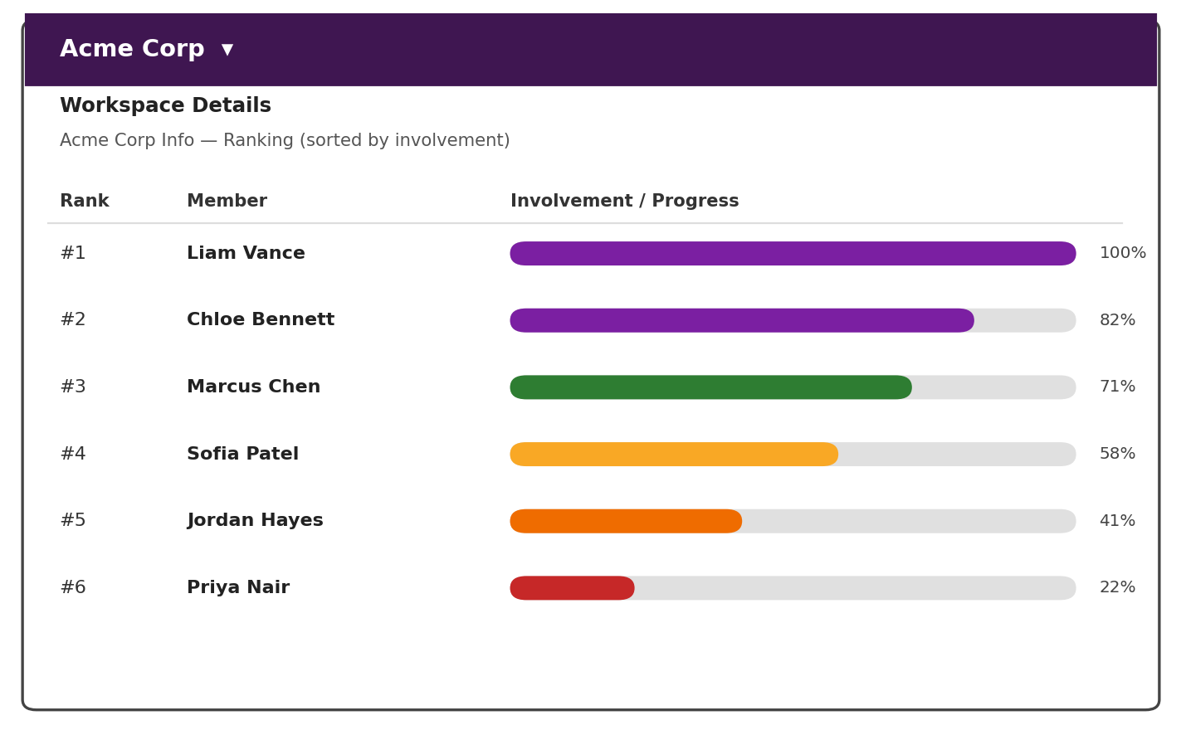
Figure 2. Rough wireframe of the workspace ranking view with relative, colour-coded progress bars.

The colour thresholds used for the bars are:
Score Range (relative to #1) | Bar Colour | Meaning
≥ 80% | Purple | Top performer band — near or at the level of the most active member
65% – 79% | Green | Strongly engaged
50% – 64% | Yellow | Moderately engaged
35% – 49% | Orange | Below-average engagement; may need a nudge
< 35% | Red | Low engagement; flagged for manager visibility

This gives an admin an at-a-glance read of the whole team's health: a workspace full of purple and green bars is thriving, while a cluster of orange and red bars signals members who may be disengaging.

6. Authentication & Authorization
TeamPulse uses Spring Security with stateless JWT (JSON Web Token) authentication rather than server-side sessions, which keeps the backend horizontally scalable. The flow has two halves: an initial login exchange that issues a token, and a per-request check that validates the token and enforces role-based permissions.
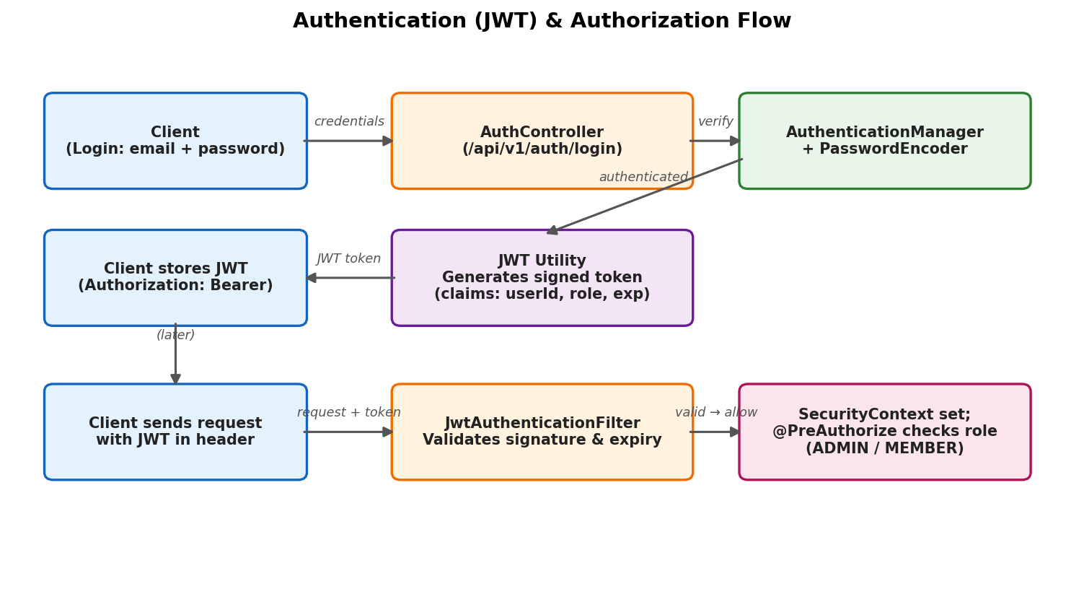
Figure 3. JWT-based authentication (login) and per-request authorization flow.

6.1 Authentication
- A member logs in with email and password; passwords are never stored in plain text — they are hashed with BCrypt via Spring Security's PasswordEncoder.
- On successful verification, the AuthenticationManager confirms identity and a JWT Utility issues a signed token embedding the user's id, role, and an expiry claim.
- The client stores the token and attaches it as an Authorization: Bearer header on every subsequent request.

6.2 Authorization
- A JwtAuthenticationFilter intercepts every incoming request, validates the token's signature and expiry, and populates Spring's SecurityContext with the authenticated user.
- Method- or endpoint-level checks (e.g. @PreAuthorize) enforce role-based access — for example, only a workspace ADMIN can remove a member or change ranking-weight configuration, while any MEMBER can view the workspace's own ranking.
- Workspace-scoped checks ensure a user can only read channels, messages, and rankings for workspaces they actually belong to (via the WORKSPACE_MEMBER relationship).

7. Backend Workflow — From Activity to Ranking Update
The sequence below traces a single member action all the way through to an updated, re-rendered ranking bar, showing how the layered backend and the ranking engine cooperate.
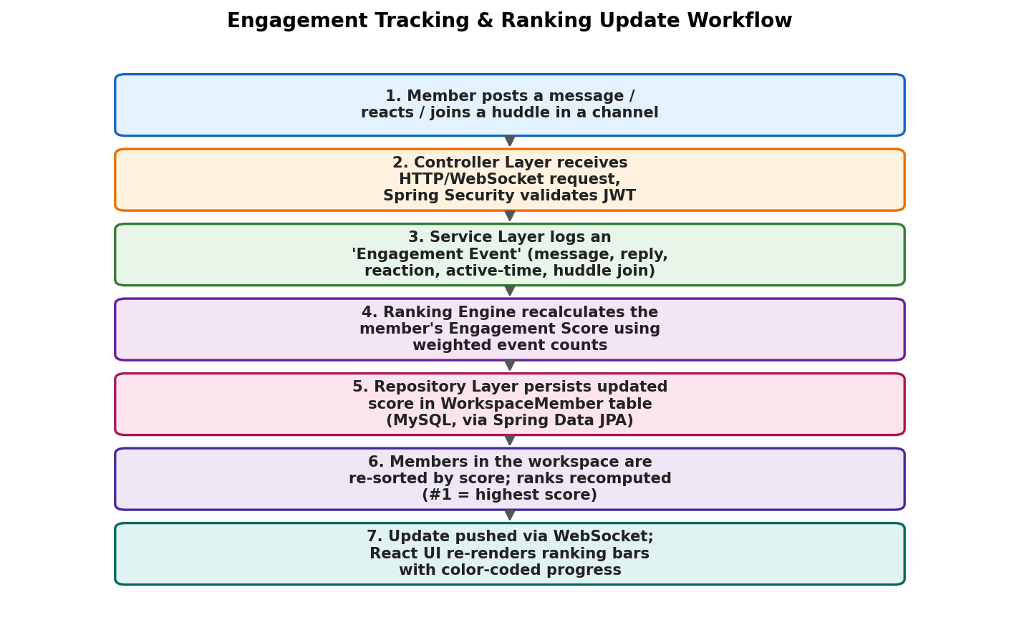
Figure 4. End-to-end workflow from a member's activity to a live ranking update.
Because scoring is incremental and push-based over WebSocket, members see the leaderboard shift in near real time as teammates participate, which is what makes the ranking feel alive rather than like a static weekly report.

8. Entity–Relationship (ER) Diagram
The data model separates identity (USER, ROLE) from workspace membership (WORKSPACE, WORKSPACE_MEMBER) and from communication (CHANNEL, CHANNEL_MEMBER, MESSAGE), with engagement tracked as its own append-only log (ENGAGEMENT_EVENT) rather than being baked into the member row. This keeps the raw activity history auditable while WORKSPACE_MEMBER.engagement_score / rank_position act as a fast, denormalised read-cache the UI queries directly.
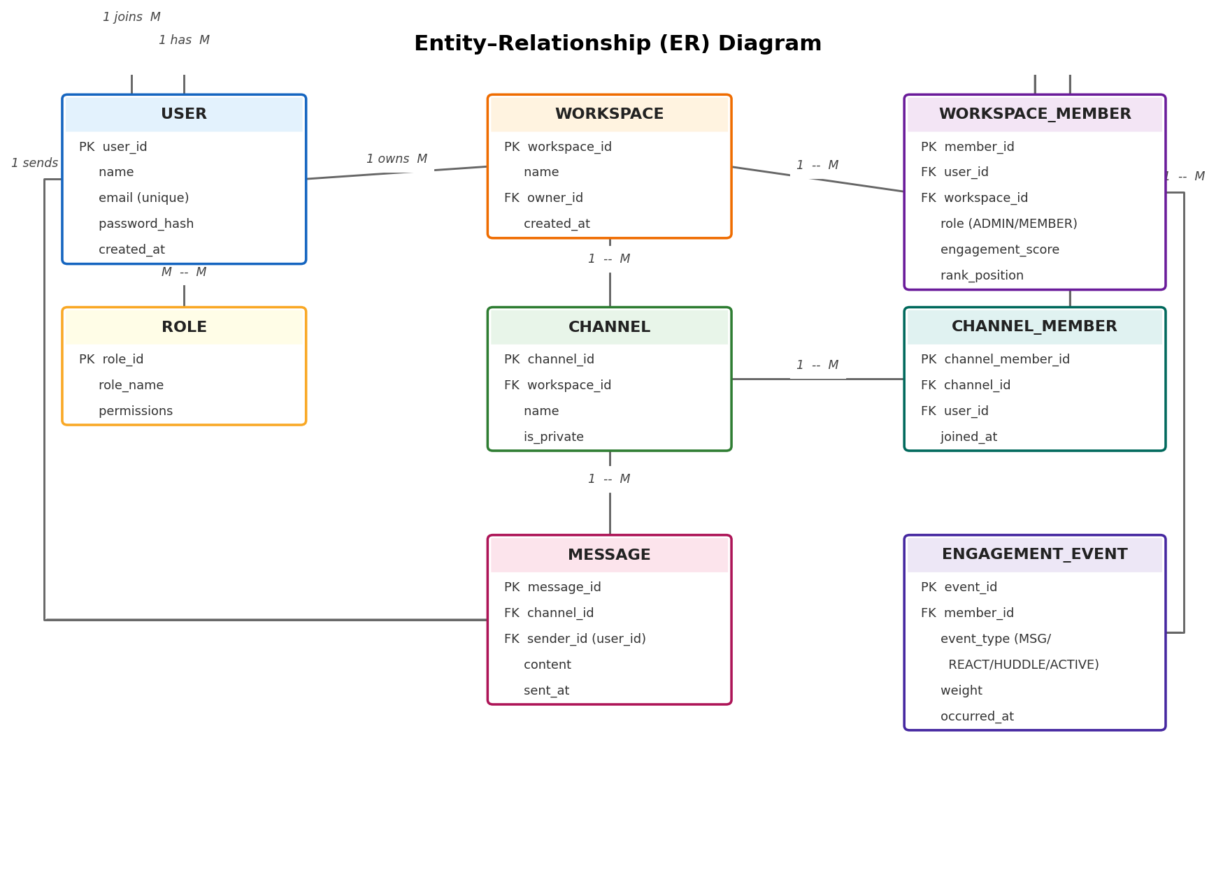
Figure 5. Entity–Relationship diagram for the TeamPulse data model.

8.1 Key Entities
- USER — a person with an account; independent of any single workspace.
- ROLE — permission set (e.g. ADMIN, MEMBER) assignable to a user.
- WORKSPACE — a team/organization space (the 'Acme Corp' in the mockup), owned by a USER.
- WORKSPACE_MEMBER — the join entity between USER and WORKSPACE; also the home of engagement_score and rank_position, since involvement is meaningful per workspace, not globally.
- CHANNEL — a topic-based room inside a workspace (e.g. #general, #random).
- CHANNEL_MEMBER — join entity between USER and CHANNEL.
- MESSAGE — a chat message posted by a user into a channel.
- ENGAGEMENT_EVENT — an append-only log of scoring-relevant actions tied to a WORKSPACE_MEMBER, used to compute and audit the engagement_score.

9. Technology Stack
The stack favours the same Spring Boot + React combination already scaffolded for the project (spring init --dependencies=web,thymeleaf,lombok,mysql,security,devtools), with the ranking and real-time features layered on top.
Layer | Technology
Frontend | React.js, React Router DOM, Fetch API / Axios, WebSocket client
Backend | Spring Boot (Web, Security, DevTools), Java, Maven
Persistence | Spring Data JPA / Hibernate, MySQL
Security | Spring Security, JWT (JSON Web Tokens), BCrypt Password Encoding
Real-time Layer | WebSocket / STOMP for live chat and live ranking updates
Build & Tooling | Apache Maven, Spring Boot CLI, Git & GitHub, npm / Vite
Hosting (optional) | Free-tier hosting such as Neon DB / Supabase for the database layer

10. Conclusion & Future Scope
TeamPulse combines familiar team-chat mechanics with a lightweight, transparent engagement-ranking layer, giving teams visibility into participation without extra manual reporting. The layered Spring Boot architecture keeps the ranking engine decoupled from messaging, the JWT-based security model keeps workspace data private and role-aware, and the append-only engagement-event log keeps the scoring auditable and tunable per workspace.
Future extensions could include: configurable scoring weights per workspace admin, weekly/monthly ranking snapshots and trend charts, badges or milestones for sustained engagement, and manager-only digest notifications for members whose engagement drops into the orange/red band.

